EUROCLUB LED WASH MOVING HEAD
SPARK 800
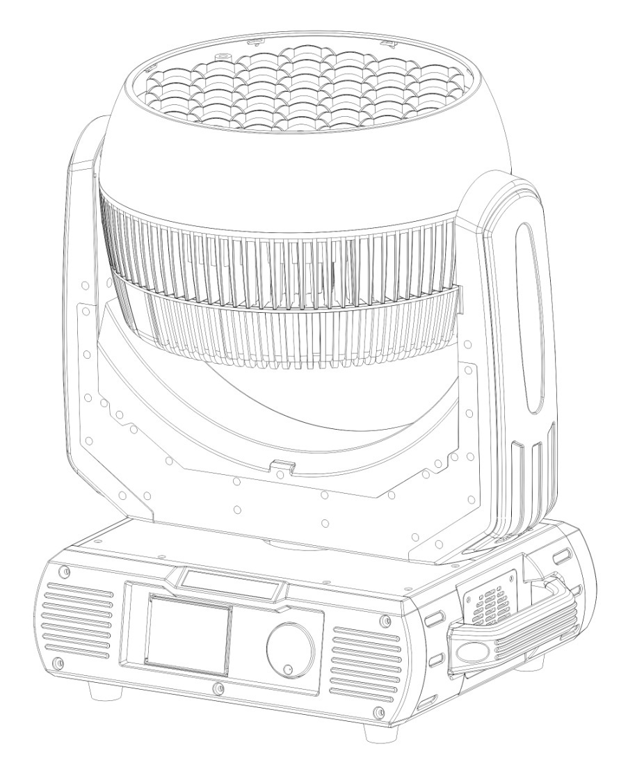

Model : SPARK 800
Weight ：17.0KG
Power ：800W
Color ：RGBW

ITEM

1. Menu ....................................................................................................................02

- Application notice ................................................................................................02

3. Parts introduction ..............................................................................................03

- Fixture size............................................................................................................03

- Product information .........................................................................................04

6. Control panel operate...........................................................................................05

7. DMX Channels.......................................................................................................09

2 Application notice

1: please check if device get loose during transportation .and ke ep regular maintenance
2: keep voltage steady-going , or the lamp can be damaged easily
3: please check the voltage if it get abnormal , do not switching on / off frequently
4: keep dry and ventilated for a long service life .
5: make sure switch off during installation and disassembly
Do not take out without authorization when fixture get abnormal
Should ask a professionals for inspection .
6: Install the stand , adjust the angel , connect the power supply and grand wire .
the computer will self - check about 30 seconds automatically after power up
7: do not look straight at light avoid any damage to eyes .
8: please use over 2.0 square wire .
9: no combustible or explosive materials around 0.5 m of light , do not touch the light by hands , 10: Make sure Disconnection of power supply when installation and maintenence .

3 Parts introduction
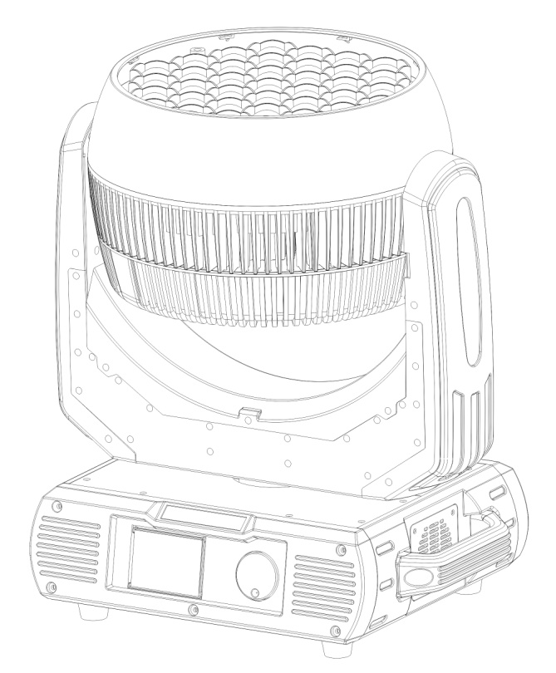

01
02
03

04
05
01 —Lens
02 —Hands
03 —Body
04 —Hands
05 —Bottom

4 size

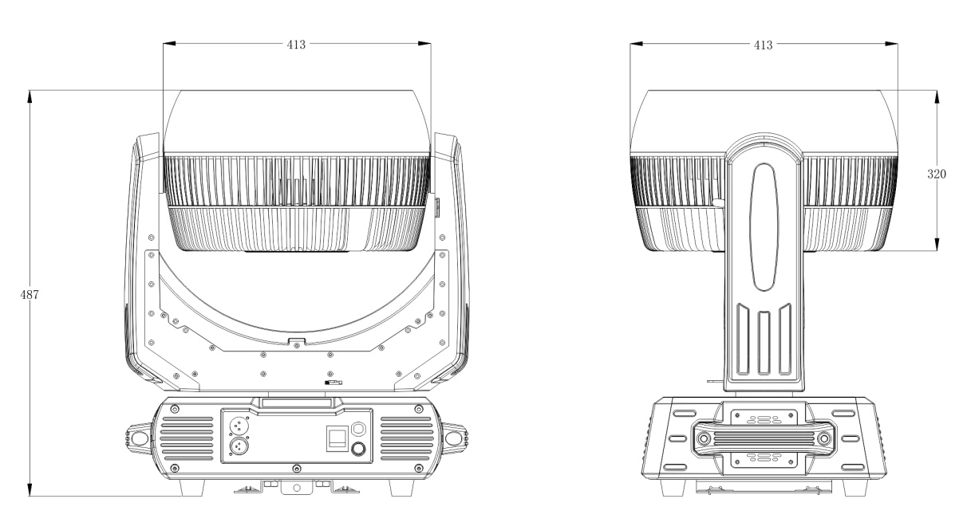

5 product information

1 : specification
Mix color equal , smooth color change , 37 pcs lamp can work as 4 group .
Use high transmittance France GAGGIONE LENSE
CH ：14/25/30CH;
Source ：15W RGBW 4 in 1 LED;
Voltage : 110-240V,50/60Hz;
Power : 800W;
Display : Touch screen ;
Lens : France Gaggione lens ，with zoom , Lens degree : 8 degree
Zoom : 7.9-38°
Dim : 0—100% linear Dim ;
Pan : 540°,8/16Bit;
Tilt : 270° , 8/16Bit;
IP: IP20;
Size : 413x320x486mm;
Carton : 535x440x585mm;
Weight: 17KG;
Gross weight ：20KG.

2: luminous diagram
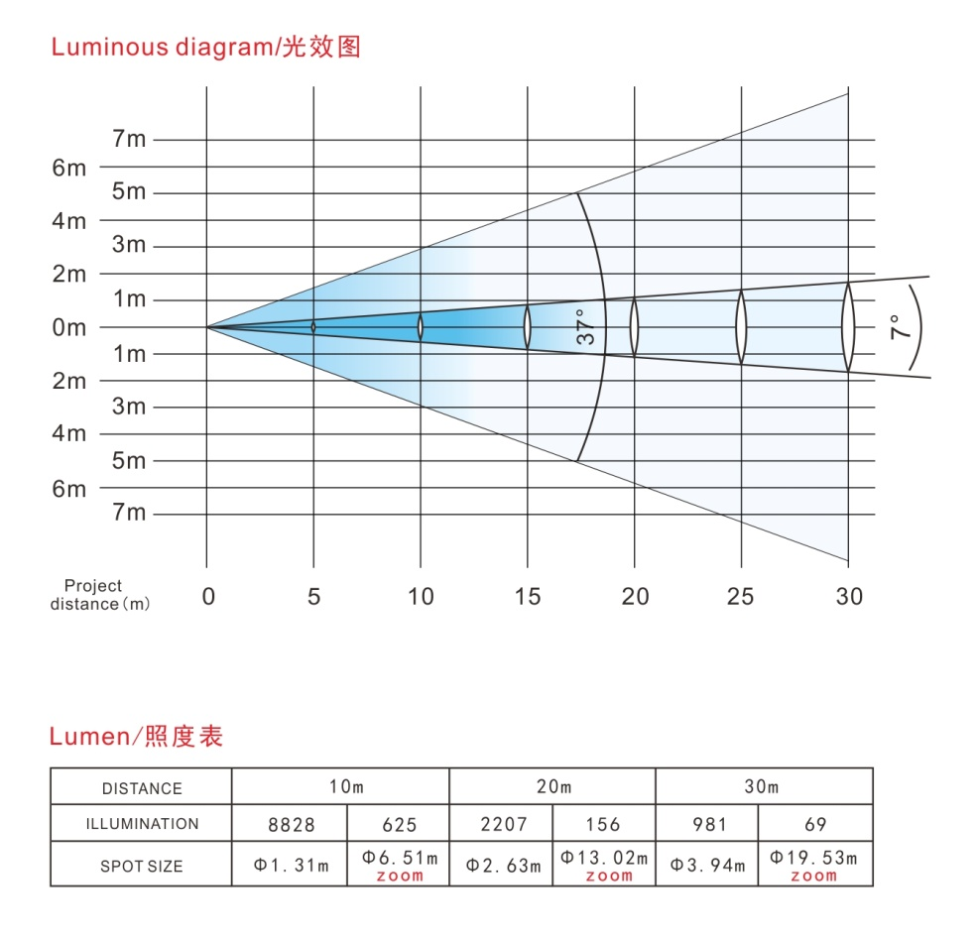

6.CONTROL PANELMENU OPERATE
SPARK 800 LCD DISPLAY CONTENTS
Main Menu | Submenu 1 |  | Submenu 2 |  | Function SET |  | Function description
DmxAddr | << |  |  |  | 001-512 |  | address minimum value 1
 | < |  |  |  |  |  | address + 1
 | > |  |  |  |  |  | address -1
 | << |  |  |  |  |  | address maximum value 512
 |  |  |  |  | SAVE |  | save date and back to main  interface
 |  |  |  |  | ESC |  | back to main interface
FEATURES SETTING | Run Mode |  |  |  | DMX |  | DMX
 |  |  |  |  | Wire |  | Inactive
 |  |  |  |  | Aoto |  | Inactive
 | Channel Mode |  |  |  | 14CH |  | 14CH
 |  |  |  |  | 25CH |  | 25CH
 |  |  |  |  | 30CH |  | 30CH
 | Pan Reverse |  |  |  | Off |  | Pan Scan Normal
 |  |  |  |  | On |  | Pan Scan Reverse
 | Tilt |  |  |  | Off |  | Tilt Scan Normal
 | Recerse |  |  |  | On |  | Tilt Scan Reverse
 | Opto Check |  |  |  | Off |  | Pan/Tilt optical sensor testing off
 |  |  |  |  | On |  | Pan/Tilt optical sensor testing on
 | PT Speed |  |  |  | Noml |  | Pan/Tilt Scan Speed setting normal
 |  |  |  |  | Slow |  | Pan/Tilt Scan Speed setting slow
 |  |  |  |  | Fast |  | Pan/Tilt Scan Speed setting fast
 | Singl Clear |  |  |  | Off |  | keep signal data
 |  |  |  |  | On |  | clear signal data
 |  |  |  |  | ADV |  | enter advanced function
 |  |  |  |  | RST |  | reset and back to main interface
 |  |  |  |  | SAVE |  | save date and back to main  interface
 |  |  |  |  | ESC |  | back to main interface
ADVANCED FUNCTION | Redress | ZEROSETTING
 |  | Pan |  |  |  | 0-255 | Motor zero calibration
 |  | Tilt
 |  | Focus
 |  |  |  |  |  | SAVE | save date and back to last  interface
 |  |  |  |  |  | > | the current value + 1
 |  |  |  |  |  | < | the current value - 1
 |  |  |  |  |  | ESC | back to last interface
 | ChanlDef |  |  |  |  |  | inactive
 | FactSett |  |  |  |  |  | inactive
 | UseManage | Limit |  |  |  | LimitTime | inactive
 |  |  |  |  |  | limitCont | inactive
 |  | DefConfig |  |  |  | YES | restore default and exit from  the current interface
 |  |  |  |  |  | NO | exit from the current interface
 |  |  |  |  |  | SAVE | save factory configuration ,exit  from current interface
 |  | FacConfig |  |  |  | EPRT | export factory configuration  exit from current interface
 |  |  |  |  |  | ESC | exit from current interface
 |  |  |  |  |  | ESC | back to last interface
UNLOCK | Venify1: |  |  |  |  | 0-255 | unlocking code
 | Venify2:
 |  |  |  |  |  | KEY | password to enter the next  interface, Otherwise the exit  from the current interface
 |  |  |  |  |  | ESC | exit from current interface
MANUAL | LAMP REST |  |  |  |  | ALL MOTER | all motors
 |  |  |  |  |  | XY MOTER | function inactive
 |  |  |  |  |  | PART MOTER | function inactive
 |  |  |  |  |  | YES | Reset the selected motor
 |  |  |  |  |  | ESC | back to last interface
 | TEST RUN | AUTO |  |  |  |  | auto
 |  | SOUND |  |  |  |  | sound control
 |  |  |  |  |  | ESC | back to main interface
 | SMULATE DMX | Beam Strobe: |  |  |  | 0-255 | manual control
 |  | Beam Dimmer:
 |  | Focus:
 |  | Pan:
 |  | Pan Fine:
 |  | Tilt:
 |  | Tilt Fine:
 |  | Function:
 |  | Beam Macro:
 |  | Beam Red:
 |  | Beam Green:
 |  | Beam Blue:
 |  | Beam White:
 |  | Colour Grad:
 |  | Gobo:
 |  | Shape Selection:
 |  | Shape Speed:
 |  | Shape Fade:
 |  | Shape R:
 |  | Shape G:
 |  | Shape B:
 |  | Shape W:
 |  | Shape Dim:
 |  | Background Dim:
 |  | Reserved:
 |  |  |  |  |  | > | current value + 1
 |  |  |  |  |  | < | current value - 1
 |  |  |  |  |  | ESC | back to last interface
 | ESC |  |  |  |  |  | back to main interface
SYSTEM INFO | DMX VALUE | CH00-CH25 |  |  |  | 0-255 | DMX value number
 | REST INFO | Pan: |  |  |  | Right/Erro | Motor reset state
 |  | Tilt:
 |  | Focus:
 |  | Pan Opto:
 |  | Tilt Opto:
 |  |  |  |  |  | ESC | back to last interface
 | OTHER INFO | Run Time: |  |  |  | 0-9999 | fixture running how many  hours
 |  | Run Count: |  |  |  | 0-9999 | fixture running times
 |  | Residue T: |  |  |  | Most | running hours unlimited
 |  | Residue C: |  |  |  | Most | running time unlimited
 |  | Type: |  |  |  | SPARK 800 | light model
 |  | Temp: |  |  |  | xxx | led temperature
 |  | Fan 1: |  |  |  | 0-9999 | Fan 1 rotate speed
 |  | Fan 2: |  |  |  | 0-9999 | Fan 2 rotate speed
 |  | Lampbrand: |  |  |  | CN/OSM | LED brand
 |  | DisVersion: |  |  |  | Vxxx | Panel software version number
 |  | XY Version: |  |  |  | Vxxx | XY Driver software version  number
 |  | M1 Version: |  |  |  | Vxxx | M1 software version number
 |  |  |  |  |  | ESC | back to last interface
 | ESC |  |  |  |  |  | back to main interface
DISPLAY SETTING | Light Set: |  |  |  |  | 1-7Lev | Backlight brightness Settings
 | Light Off: |  |  |  |  | On | backlight keeps on
 |  |  |  |  |  | 1Min | backlight off in 1 minutes
 |  |  |  |  |  | 2Min | backlight off in 2 minutes
 |  |  |  |  |  | 3Min | backlight off in 3 minutes
 | Menu Back: |  |  |  |  | Off | close menu to return  automatically
 |  |  |  |  |  | 1Min | The menu returns after 1  minute
 |  |  |  |  |  | 2Min | The menu returns after 2  minute
 |  |  |  |  |  | 3Min | The menu returns after 3  minute
 | Light Flash: |  |  |  |  | Off | Closing backlight flashing
 |  |  |  |  |  | On | open backlight flashing
 | Touch Cali: |  |  |  |  | Off | Close touch calibration
 |  |  |  |  |  | On | open touch calibration
 |  |  |  |  |  | SAVE | save the date and back to main  interface
 |  |  |  |  |  | ESC | back to main interface
DIMMER SETTING | Dimmer Mode: |  |  |  |  | Fast | fast
 |  |  |  |  |  | Noml | smooth
 | Balance SW: |  |  |  |  | Off | The white balance off
 |  |  |  |  |  | On | The white balance on
 | Balance Red: |  |  |  |  | 0-255 | The white balance red
 | BalanceGreen: |  |  |  |  |  | The white balance green
 | Balance Blue: |  |  |  |  |  | The white balance blue
 | Balance White: |  |  |  |  |  | The white balance white

SPARK 800 CHANNEL LIST
14CH | 25CH | 30CH | Function | DMX value | Description
1 | 1 | 1 | Strobe | 0 -19 | Strobe OFF
 |  |  |  | 20 -24 | Strobe ON
 |  |  |  | 25 -64 | Strobe Fast-Slow
 |  |  |  | 65 -69 | Strobe ON
 |  |  |  | 70 -84 | Slow input Strobe Fast-Slow
 |  |  |  | 85 -89 | Strobe ON
 |  |  |  | 90 -104 | Slow output Strobe Fast-Slow
 |  |  |  | 105-109 | Strobe ON
 |  |  |  | 110-124 | Random Strobe Fast-Slow
 |  |  |  | 125-129 | Strobe ON
 |  |  |  | 130-144 | Random Slow input Strobe Fast-Slow
 |  |  |  | 145-149 | Strobe ON
 |  |  |  | 150-164 | Random Slow output Strobe Fast-Slow
 |  |  |  | 165-169 | Strobe ON
 |  |  |  | 170-184 | Pulse Strobe Fast-Slow
 |  |  |  | 185-189 | Strobe ON
 |  |  |  | 190-204 | Random Pulse Strobe Fast-Slow
 |  |  |  | 205-209 | Strobe ON
 |  |  |  | 210-224 | Strobe Fast-Slow
 |  |  |  | 225-229 | Strobe ON
 |  |  |  | 230-244 | Exposure Strobe Fast-Slow
 |  |  |  | 245-255 | Strobe ON
2 | 2 | 2 | Dimmer | 0 -255 | Linear Dimmer Dark-Bright
3 | 3 | 3 | Focus | 0 -255 | Linear Focus
4 | 4 | 4 | Pan Rotation | 0 -255 | 0~540 degree
5 | 5 | 5 | Pan Fine | 0 -255 | Pan Fine
6 | 6 | 6 | Tilt Rotation | 0 -255 | 0~270 degree
7 | 7 | 7 | Tilt Fine | 0 -255 | Tilt Fine
8 | 8 | 8 | Function set | 0 -9 | No function
 |  |  |  | 10 -14 | Whole light Reset
 |  |  |  | 15 -39 | No function
 |  |  |  | 40 -44 | XY Normal mode
 |  |  |  | 45 -49 | XY Fast mode
 |  |  |  | 50 -54 | XY Slow mode
 |  |  |  | 55-255 | No function
9 | 9 | 9 | Color tempreture and Color | 0 -9 | No function
 |  |  |  | 10 -14 | Red
 |  |  |  | 15 -19 | Green
 |  |  |  | 20 -24 | Blue
 |  |  |  | 25 -29 | White
 |  |  |  | 30 -34 | 2300
 |  |  |  | 35 -39 | 2500
 |  |  |  | 40 -44 | 2700
 |  |  |  | 45 -49 | 3000
 |  |  |  | 50 -54 | 3200
 |  |  |  | 55 -59 | 3300
 |  |  |  | 60 -64 | 3700
 |  |  |  | 65 -69 | 4300
 |  |  |  | 70 -74 | 4500
 |  |  |  | 75 -79 | 4600
 |  |  |  | 80 -84 | 5000
 |  |  |  | 85 -89 | 5500
 |  |  |  | 90 -94 | 5600
 |  |  |  | 95 -99 | 6500
 |  |  |  | 100-104 | Light yellow
 |  |  |  | 105-109 | Apple Green
 |  |  |  | 110-114 | Pink
 |  |  |  | 115-119 | Orange
 |  |  |  | 120-124 | Deep Orange
 |  |  |  | 125-129 | UV
 |  |  |  | 130-134 | No function
 |  |  |  | 135-174 | Color clockwise run from fast to slow
 |  |  |  | 175-179 | Stop
 |  |  |  | 180-219 | Color anticlockwise run from slow to fast
 |  |  |  | 220-224 | No function
 |  |  |  | 225-255 | Random color Fast-Slow
10 | 10 | 10 | Red beam | 0-255 | Red Dimmer Dark-Bright
11 | 11 | 11 | Green beam | 0-255 | Green Dimmer Dark-Bright
12 | 12 | 12 | Blue beam | 0-255 | blue dark - bright
13 | 13 | 13 | White beam | 0-255 | white dark- bright
14 | 14 | 14 | Color slow change | 0 -7 | No function
 |  |  |  | 8 -39 | Red to Yellow
 |  |  |  | 40 -71 | Yellow to Green
 |  |  |  | 72 -103 | Green to Cyan
 |  |  |  | 136-167 | Blue to Magenta
 |  |  |  | 168-199 | Magenta to Red
 |  |  |  | 200-231 | Red to White
 |  |  |  | 232-255 | Color change slow - fast
* | 15 | * | LED gobo | 0 -4 | NO gobo
 |  |  |  | 5 -9 | Gobo1
 |  |  |  | 10 -14 | Gobo2
 |  |  |  | 15 -19 | Gobo3
 |  |  |  | … | …
 |  |  |  | 190 -194 | Gobo38
 |  |  |  | 195 -199 | Gobo39
 |  |  |  | 200 -204 | Gobo40
 |  |  |  | 205 -224 | Gobo change slow down
 |  |  |  | 225 -234 | stop
 |  |  |  | 235 -255 | Gobo change speed up
* | 16 | * | Built-in effects | 0 -4 | No function
 |  |  |  | 5 -34 | Built-in effects1
 |  |  |  | 35 -64 | Built-in effects2
 |  |  |  | 65 -94 | Built-in effects3
 |  |  |  | 95 -124 | Built-in effects4
 |  |  |  | 125-154 | Built-in effects5
 |  |  |  | 155-184 | Built-in effects6
 |  |  |  | 185-255 | after 1 mins auto change
* | 17 | * | Effect speed | 0 -255 | LED built-in effect speed Slow-Fast
* | 18 | * | Effect slow input | 0 -255 | LED built-in effects Gradient Overlay
* | 19 | * | Effect red | 0 -255 | Red Dimmer Dark-Bright
* | 20 | * | Effect green | 0 -255 | Green Dimmer Dark-Bright
* | 21 | * | Effect blue | 0 -255 | Blue Dimmer Dark-Bright
* | 22 | * | Effect white | 0 -255 | White Dimmer Dark-Bright
* | 23 | * | Effect Dimmer | 0 -255 | Dimmer Dark-Bright
* | 24 | * | Effect backlight | 0 -255 | Dimmer Dark-Bright
* | 25 | * | Reserve | 0 -255
* | * | 15 | R1Dimmer | 0 -255 | R1Dimmer Dark-Bright
* | * | 16 | G1Dimmer | 0 -255 | G1Dimmer Dark-Bright
* | * | 17 | B1Dimmer | 0 -255 | B1Dimmer Dark-Bright
* | * | 18 | W1Dimmer | 0 -255 | W1Dimmer Dark-Bright
* | * | … | … | …
* | * | 27 | R4Dimmer | 0 -255 | R4Dimmer Dark-Bright
* | * | 28 | G4Dimmer | 0 -255 | G4Dimmer Dark-Bright
* | * | 29 | B4Dimmer | 0 -255 | B4Dimmer Dark-Bright
* | * | 30 | W4Dimmer | 0 -255 | W4Dimmer Dark-Bright

